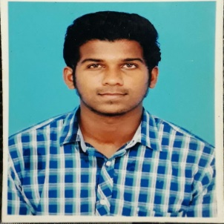

Venkatraju V
31/11, BV Nagar 1st Street,
rajuvenkat07@gmail.com
Nanganallur, Chennai-600114
+91-8939013052


PERSONAL DETAILS
Bachelor of Engineering (BE) in Mechanical Engineering in New Prince Shri Bhavani College of Engineering and Technology
Sex: Male |Date of birth: 18-12-1996| Nationality: Indian| Language: English,Tamil, Telugu
OBJECTIVE

- Obtain a dynamic challenging leadership position applying creative problem solving
techniques in the client environment and also to an opportunity to leverage my managerial skills utmost.
EDUCATIONAL DETAILS

Course | Institution | Board/  University | Year of  Completion | Marks %  / CGPA
X | New Prince Matriculation Higher Secondary School, Chennai. | Matriculation | 2011 | 83
XII | New Prince Matriculation Higher Secondary School, Chennai. | State Board | 2013 | 66
B.E.  Mechanical  Engineering | New Prince Shri Bhavani College of Engineering and Technology,Chennai. | Anna University | 2017 | 6.50

COMPUTER PROFICIENCY

- MS Office
- Python
- C,C++
- Creo, AutoCad, SolidWorks

PERSONAL ACHIEVEMENTS

  - Have won the Anna University Zonal Tournament for the year 2016-2017.

  - Taken up an innovative project named Gyro bike and Material Science project named Investigation on Mechanical Properties of Hybrid Metal Matrix Composites during the year 2016-2017.

  - Head of Planning and Organization Dept. of conducting National Level Technical Symposium held at college premises in the year 2015-2016.

  - Organized many Book Readers meet ups happening in Chennai Region

  - Published a journal regarding Gyro Bikes on International Journal of Advance Research and Innovative Ideas in Education.

  - Active Point of Contact for Blood Donation by many organizations.
HOBBIES

    - International relations

    - Environmentalist

    - studying about public policy and social sciences

    - Cricket and Basket ball

Declaration
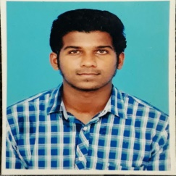
I, Venkatraju, hereby declare that the information contained herein is true and correct to the best of my knowledge and belief.

____________________________
VENKATRAJU.V Chennai, TamilNadu
MARCH 30, 2019

